Homework #6
Due Thursday 11/9
Write 3 equivalent fractions for each fractions below.
Original Fraction | Equivalent #1 | Equivalent #2 | Equivalent #3
$$\frac{2}{7}$$
$$\frac{3}{11}$$
$$\frac{7}{9}$$
$$\frac{1}{17}$$
$$\frac{3}{10}$$

Decide if the following are similar, congruent, or neither.
a. | b. | c.
d. | e. | f.

Fill in the missing corresponding sides and angles for the figures below.
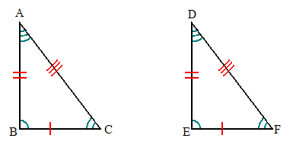 | $AB≅______$ $∠BAC≅______$  $_____≅EF$ $_____≅∠DFE$  $AC≅______$ $∠CBA≅_____$
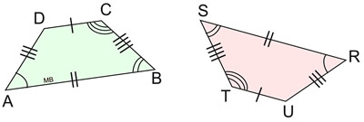 | $AD≅______$ $∠ADC≅_____$  $DC≅______$ $∠DCB≅_____$  $CB≅______$ $∠CBA≅_____$  $BA≅______$ $∠BAD≅_____$

Determine if the following sets of figures are similar or not. Justify your reasoning.

The figures below are similar. Identify the corresponding sides using your knowledge of similar figures.

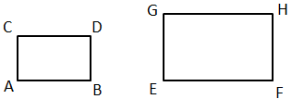 | Side AB corresponds to ________  Side BD corresponds to ________  Side CD corresponds to ________  Side AC corresponds to ________

The figures below are similar. Identify the corresponding sides using your knowledge of similar figures.

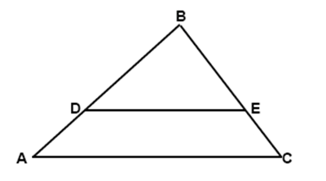
Side AB corresponds to ________

Side BC corresponds to ________

Side AC corresponds to ________

Determine the length of the missing side using your understanding of similar figures.

Solve for Side Z in the figure below using your knowledge of similar figures.

Side Z=___________

Label the corresponding sides between the two similar figures below. Remember to use the appropriate number of hash marks to represent corresponding sides.

