HW #7
DUE Friday ____________
Solve the following proportions for the missing variable.
- $\frac{x}{9}=\frac{2}{18}$ 2. $\frac{2}{m}=\frac{3}{12}$
EXAMPLE
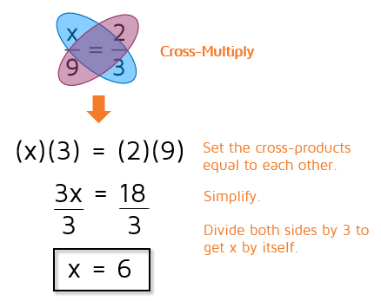

3. $\frac{6}{18}=\frac{2}{y}$ 4. $\frac{y}{8}=\frac{3}{2}$

The following polygons are similar. Use a proportion to find the missing side lengths.
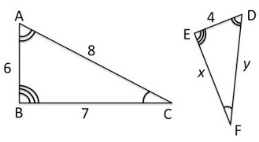
5.

x=_____________ y=_______________

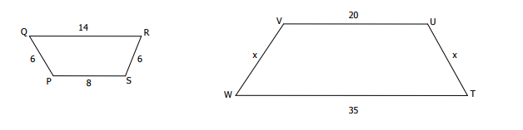
6.

x=__________
Convert the following values to the desired unit.

7. 32 yds. to m 8. 87 in. to cm

9. 3 miles to ft. 10. 10,280 mm to cm

11. 14 ft. to yards to meters to centimeters

Find the missing length in each of the nested triangles below.
12. | 13.
14. | 15.

